https://www.youtube.com/playlist?list=PLkhF8zTRdky_dEoAQMcActWjbaVLLL5Wv

**prog 1 :- group by city ---- groupingBy - Function**

package test;

public class Employee {

private String city;

private int id;

private String name;

public String getCity() {

return city;

}

public void setCity(String city) {

this.city = city;

}

public int getId() {

return id;

}

public void setId(int id) {

this.id = id;

}

public String getName() {

return name;

}

public void setName(String name) {

this.name = name;

}

}

package test;

import java.util.ArrayList;

import java.util.List;

import java.util.Map;

import java.util.stream.Collectors;

public class TestDemo {

public static void main(String[] args) {

List<Employee> emp = new ArrayList<Employee>();

createEmployeeList(emp);

}

private static void createEmployeeList(List<Employee> emp) {

Employee e1 = new Employee();

e1.setCity("allahabad");

e1.setId(1);

e1.setName("saurabh");

Employee e2 = new Employee();

e2.setCity("bangalore");

e2.setId(2);

e2.setName("ankit");

emp.add(e1);

emp.add(e2);

Map<String, List<Employee>> emp1 = emp.stream().collect(Collectors.groupingBy(Employee::getCity));

emp1.forEach((key, value) -> System.out.println("city " + key + "employees " + value));

}

}

output

city bangaloreemployees [test.Employee@7ba4f24f]

city allahabademployees [test.Employee@3b9a45b3]

**prog 2 array multiply ---- reduce (binaryOperator)----biFunction**

reduce() method combines a sequence of elements into a single element. It achieves this by applying a reduction operation, which is to apply a binary operator on each element in the sequence to reduce it to a single value.

package test;

import java.util.Arrays;

import java.util.List;

import java.util.Optional;

public class Multiply {

public static void main(String[] args) {

Integer[] num = { 1, 2, 3, 4, 5 };

List<Integer> asList = Arrays.asList(num);

Optional<Integer> output = asList.stream().reduce((a,b)->a*b);

if(output.isPresent())

{

System.out.println(output.get());

}else

{

System.out.println("not present");

}

}

}

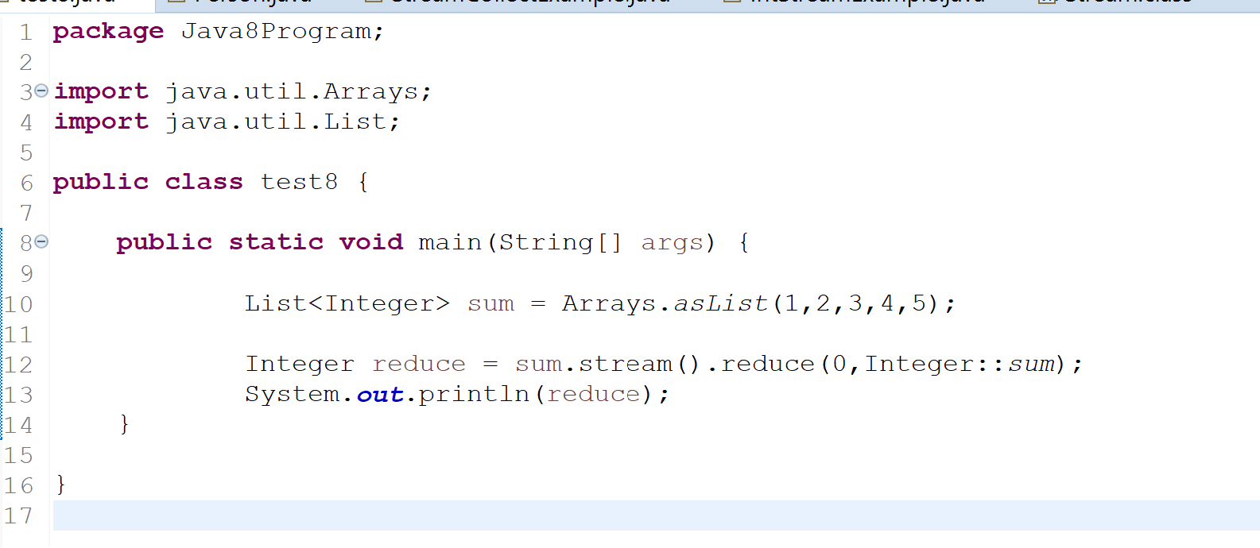

**prog 3: sort employee using comparator**

package test;

import java.util.ArrayList;

import java.util.Comparator;

import java.util.List;

public class TestDemo1 {

public static void main(String[] args) {

List<Employee> emp = new ArrayList<Employee>();

createEmployeeList(emp);

emp.sort(Comparator.comparing(Employee::getName));

emp.forEach(x -> System.out.println(x.getName() + " " + x.getCity()));

// reversed

emp.sort(Comparator.comparing(Employee::getName).reversed());

emp.forEach(x -> System.out.println(x.getName() + " " + x.getCity()));

//multiple sorting

emp.sort(Comparator.comparing(Employee::getName).thenComparing(Employee::getCity));

}

private static void createEmployeeList(List<Employee> emp) {

Employee e1 = new Employee();

e1.setCity("allahabad");

e1.setId(1);

e1.setName("saurabh");

Employee e2 = new Employee();

e2.setCity("bangalore");

e2.setId(2);

e2.setName("ankit");

Employee e3 = new Employee();

e3.setCity("bangalore");

e3.setId(3);

e3.setName("lucknow");

emp.add(e1);

emp.add(e2);

emp.add(e3);

}

}

**prog 4 : how to reuse stream in java 8**

package test;

import java.util.function.Supplier;

import java.util.stream.Stream;

public class ReuseStream {

public static void main(String[] args) {

String[] inputArray = { "cat", "dog", "goat", "cat" };

// Stream<String> stream = Arrays.asList(inputArray).stream();

//

// stream.forEach(x -> System.out.println(x));

Supplier<Stream<String>> inputString = () -> Stream.of(inputArray);

inputString.get().forEach(x -> System.out.println(x));

long count = inputString.get().filter(x -> "cat".equals(x)).count();

System.out.println(count);

}

}

prog 5 : find employee age > 10

package test;

import java.util.ArrayList;

import java.util.List;

import java.util.stream.Collectors;

public class TestDemo {

public static void main(String[] args) {

List<Employee> emp = createEmployeeList();

List<Employee> empDetails = emp.stream().filter(emp1 -> emp1.getAge() > 10).collect(Collectors.toList());

empDetails.forEach(System.out::println);

}

private static List<Employee> createEmployeeList() {

List<Employee> empList = new ArrayList<Employee>();

Employee e1 = new Employee();

e1.setCity("bangalore");

e1.setId(1);

e1.setName("saurabh");

e1.setAge(10);

Employee e2 = new Employee();

e2.setCity("bangalore");

e2.setId(2);

e2.setName("ankit");

e2.setAge(20);

empList.add(e1);

empList.add(e2);

return empList;

}

}

How to find the list of employees in age between 25-35 and have held the designation of Manager or Lead using stream api? [closed]

List<Emplyes> empFiltred = employes.stream().

filter(p -> p.getAge() > 25 && p.getAge() < 35).

filter(p -> p.getDesignations().contains("Manager") || p.getDesignations().contains("Lead")).

collect(Collectors.toList());

**prog 6 : java 8 interview question**

**java 8 features**

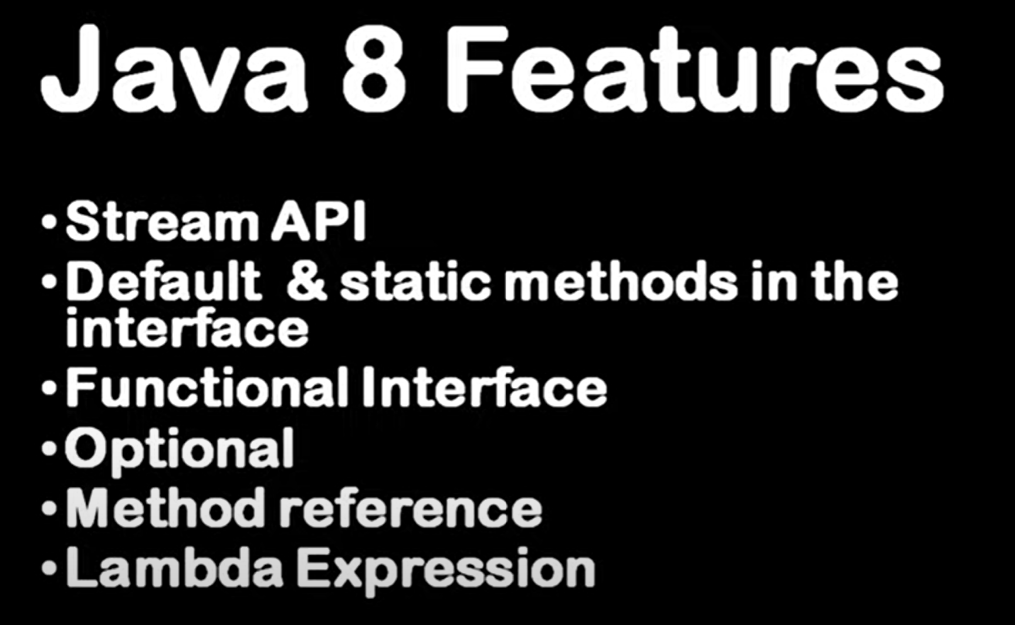

**Advantages**

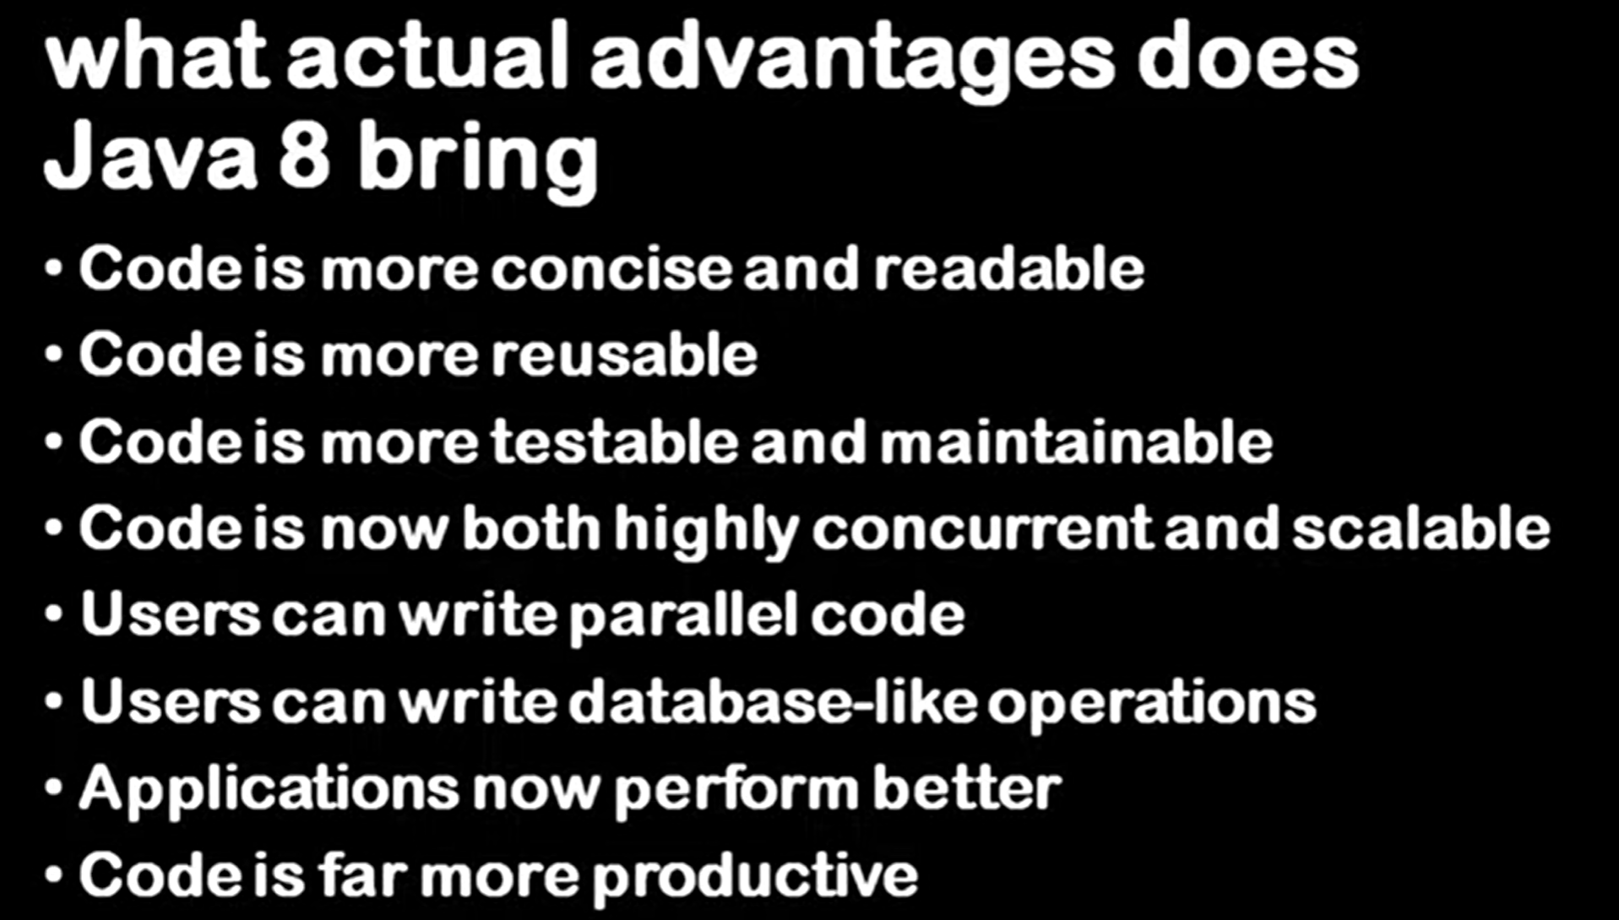

**PermGen (Permanent Generation)** is a special heap space separated from the main memory heap. The JVM keeps track of loaded class metadata in the PermGen. Additionally, the JVM stores all the static content in this memory section

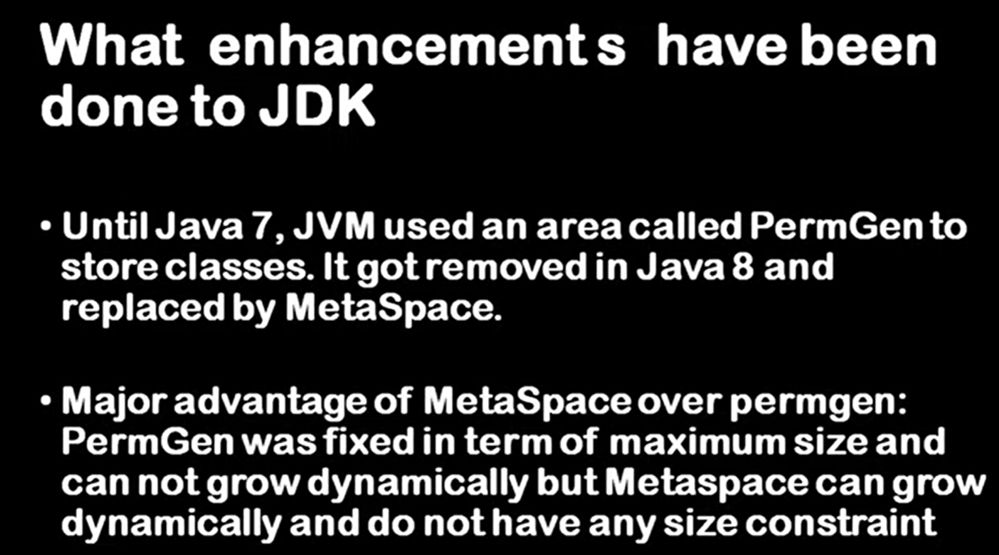

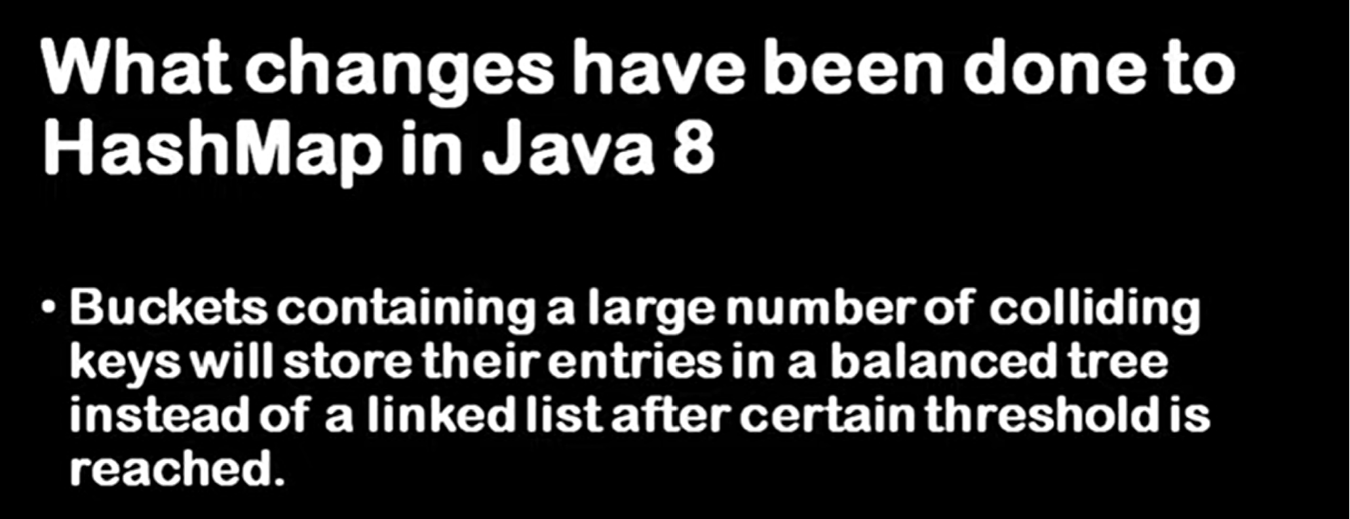

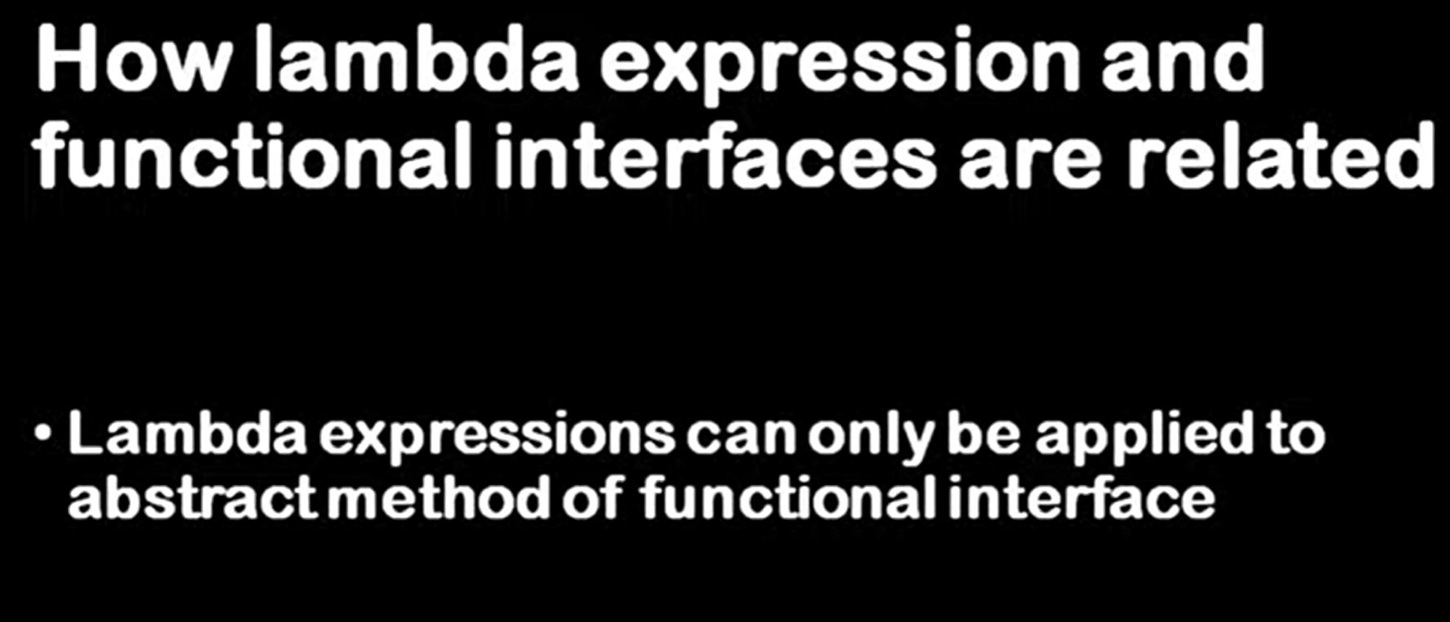

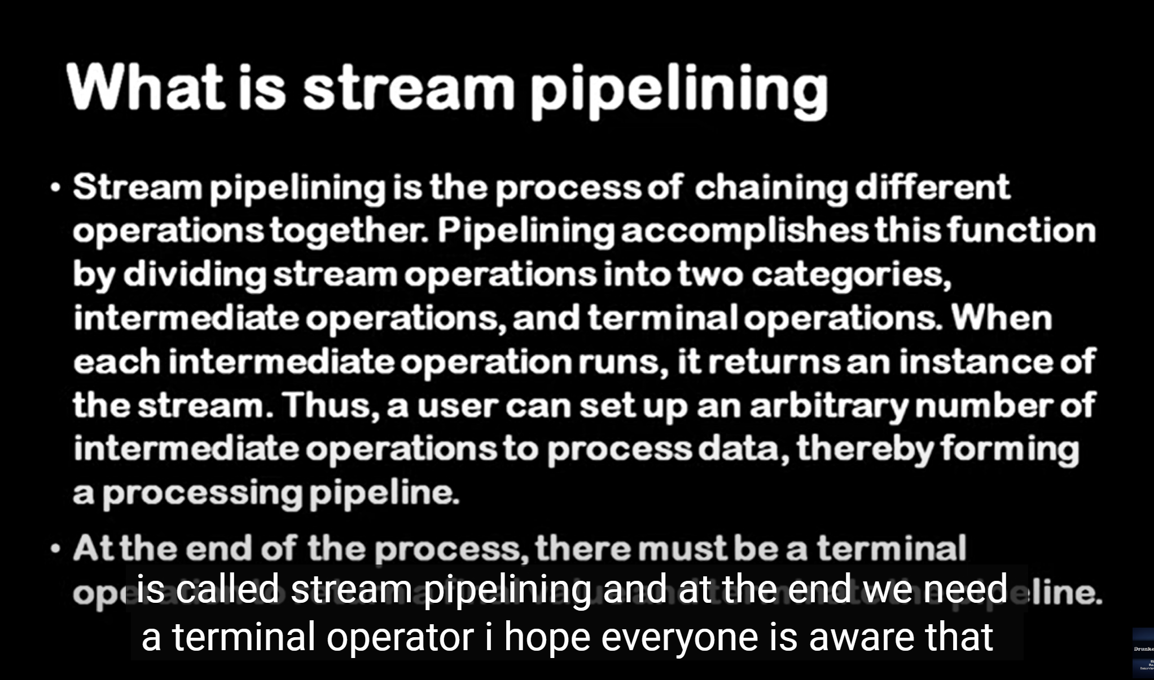

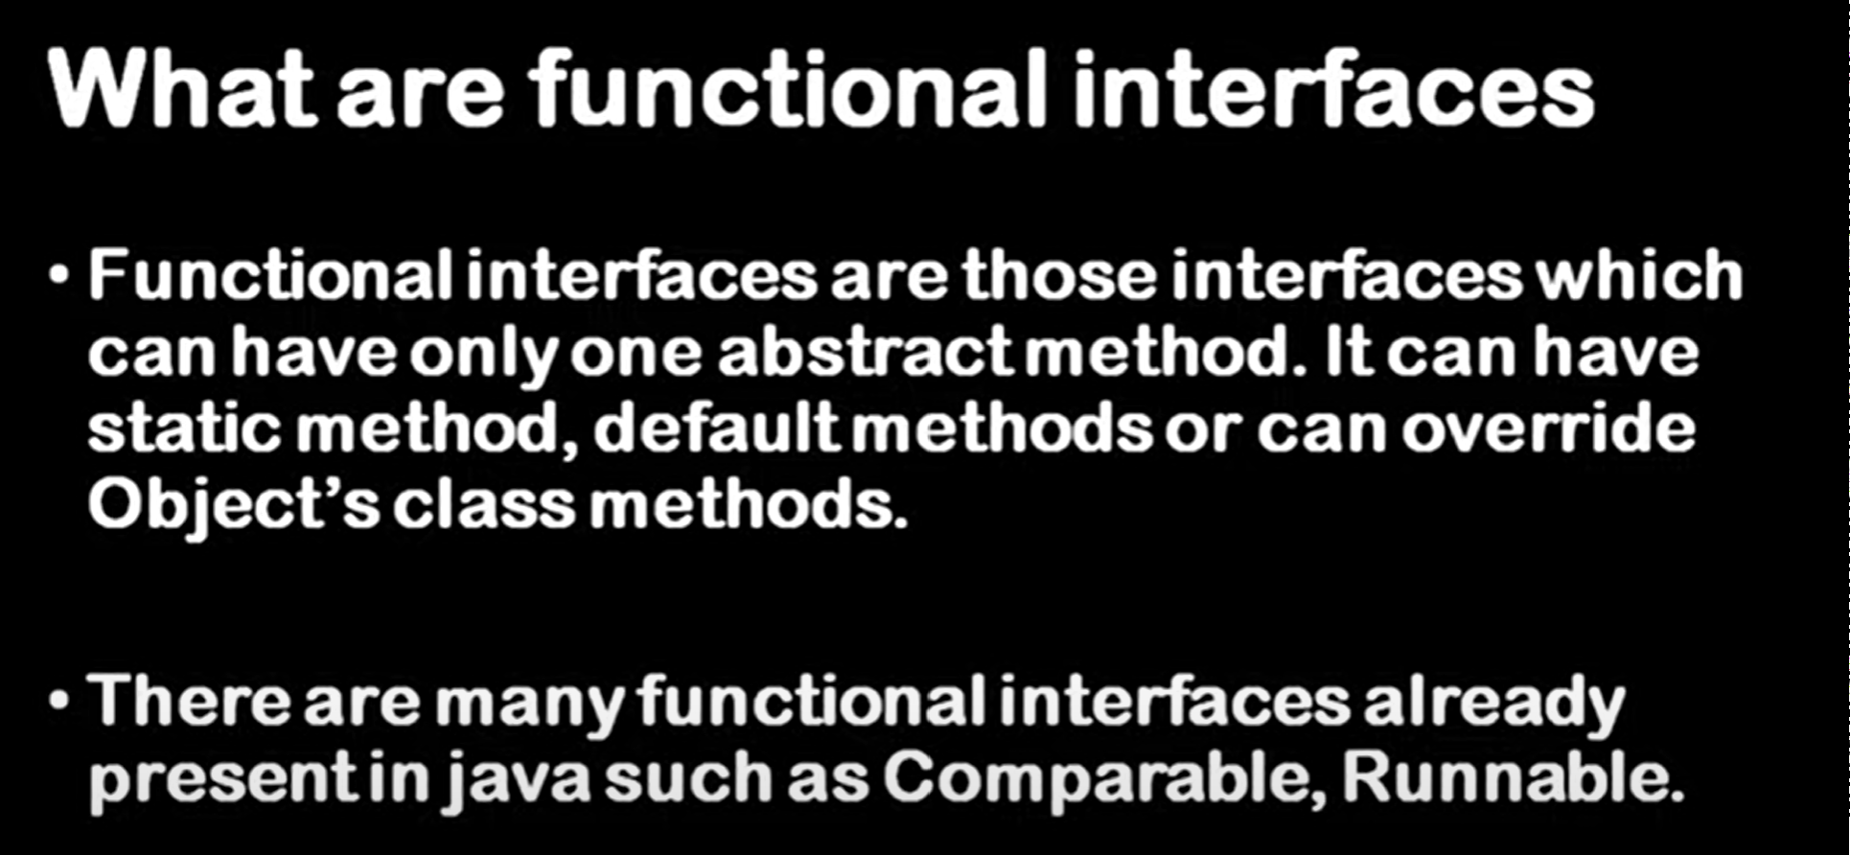

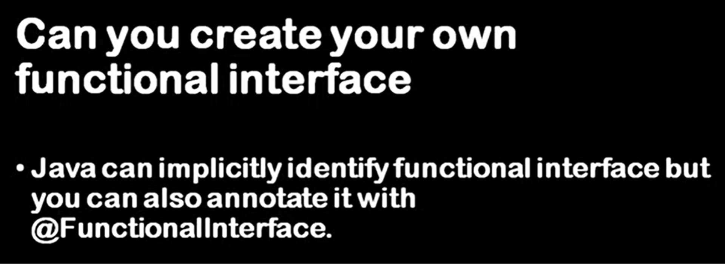

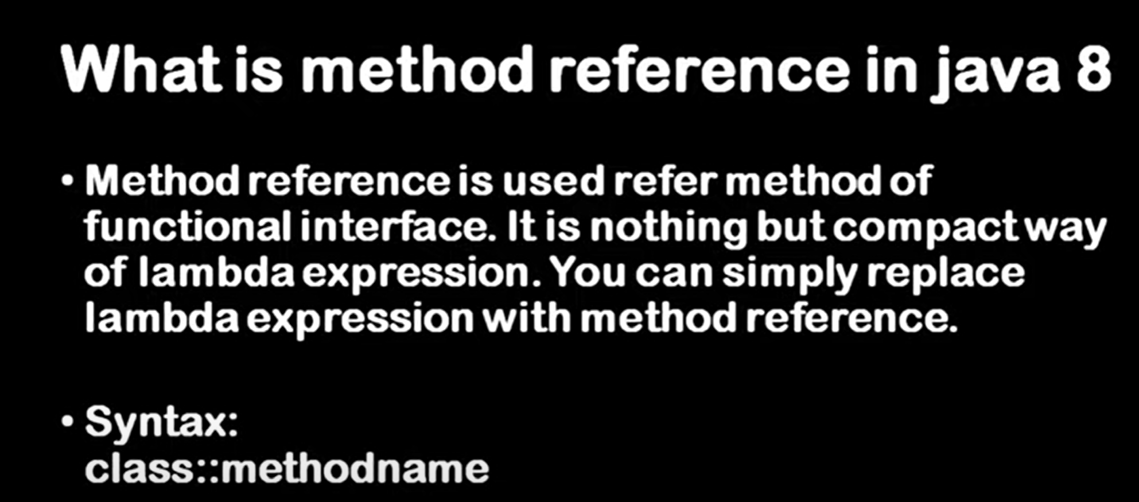

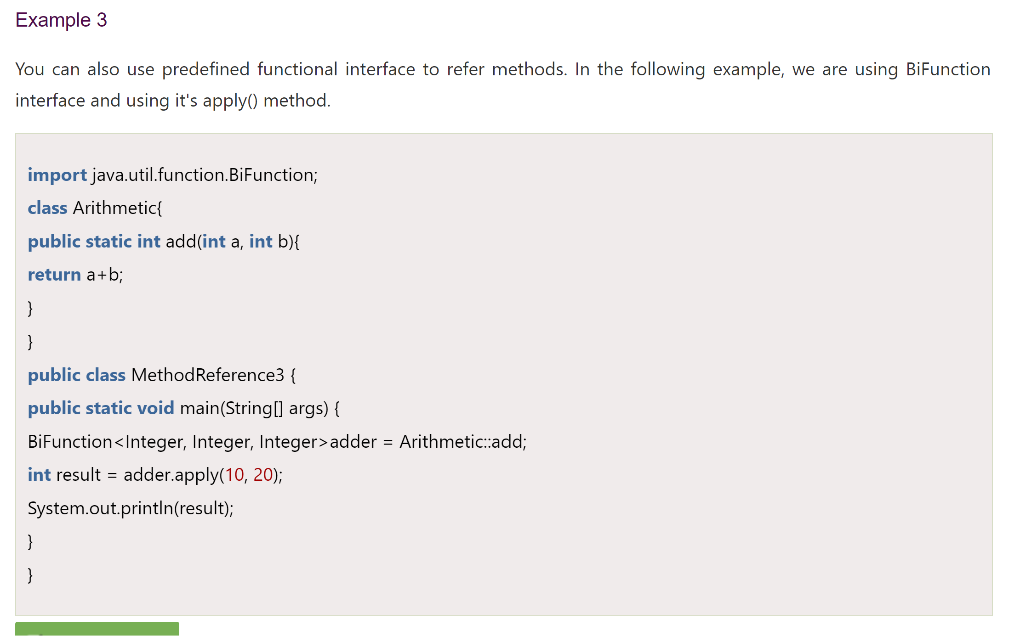

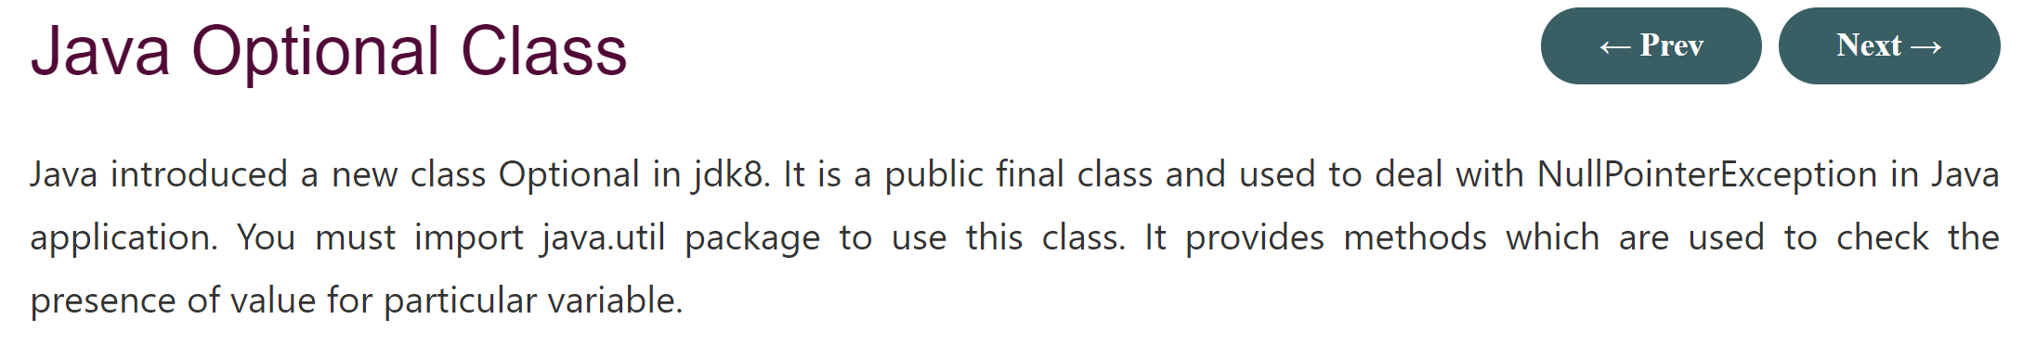

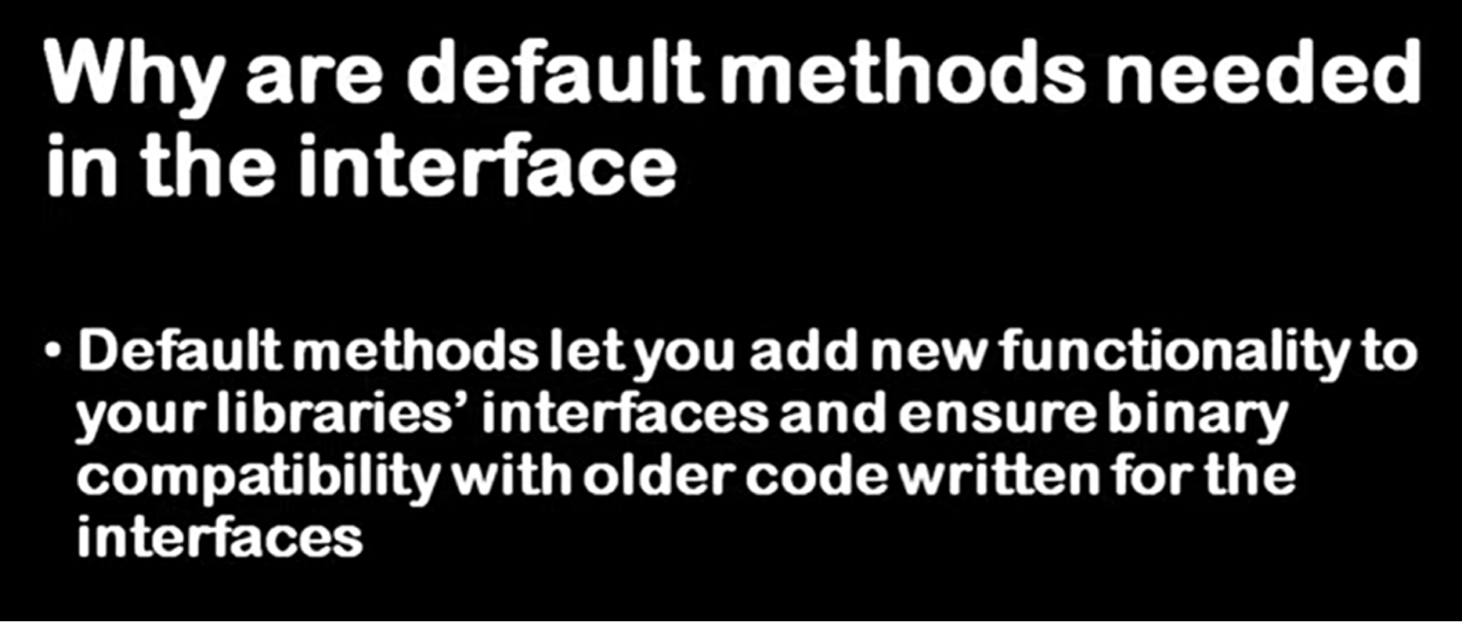

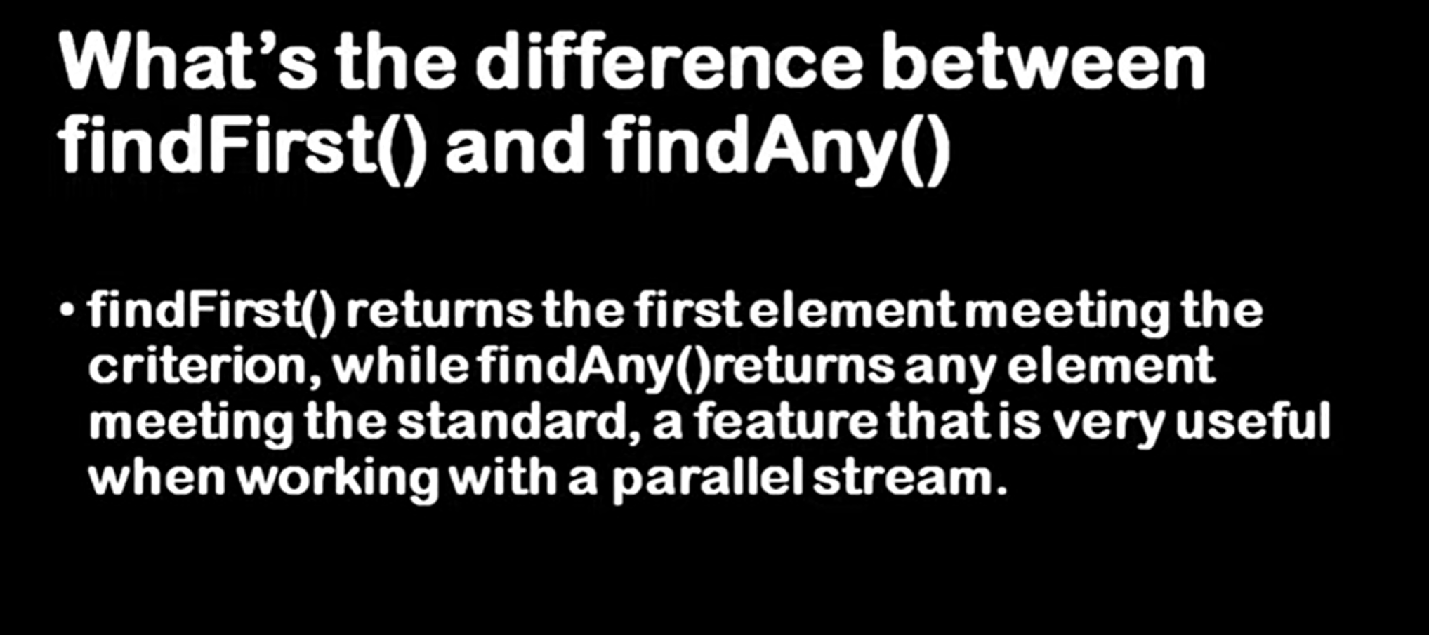

**Prog 7 : string joiner**

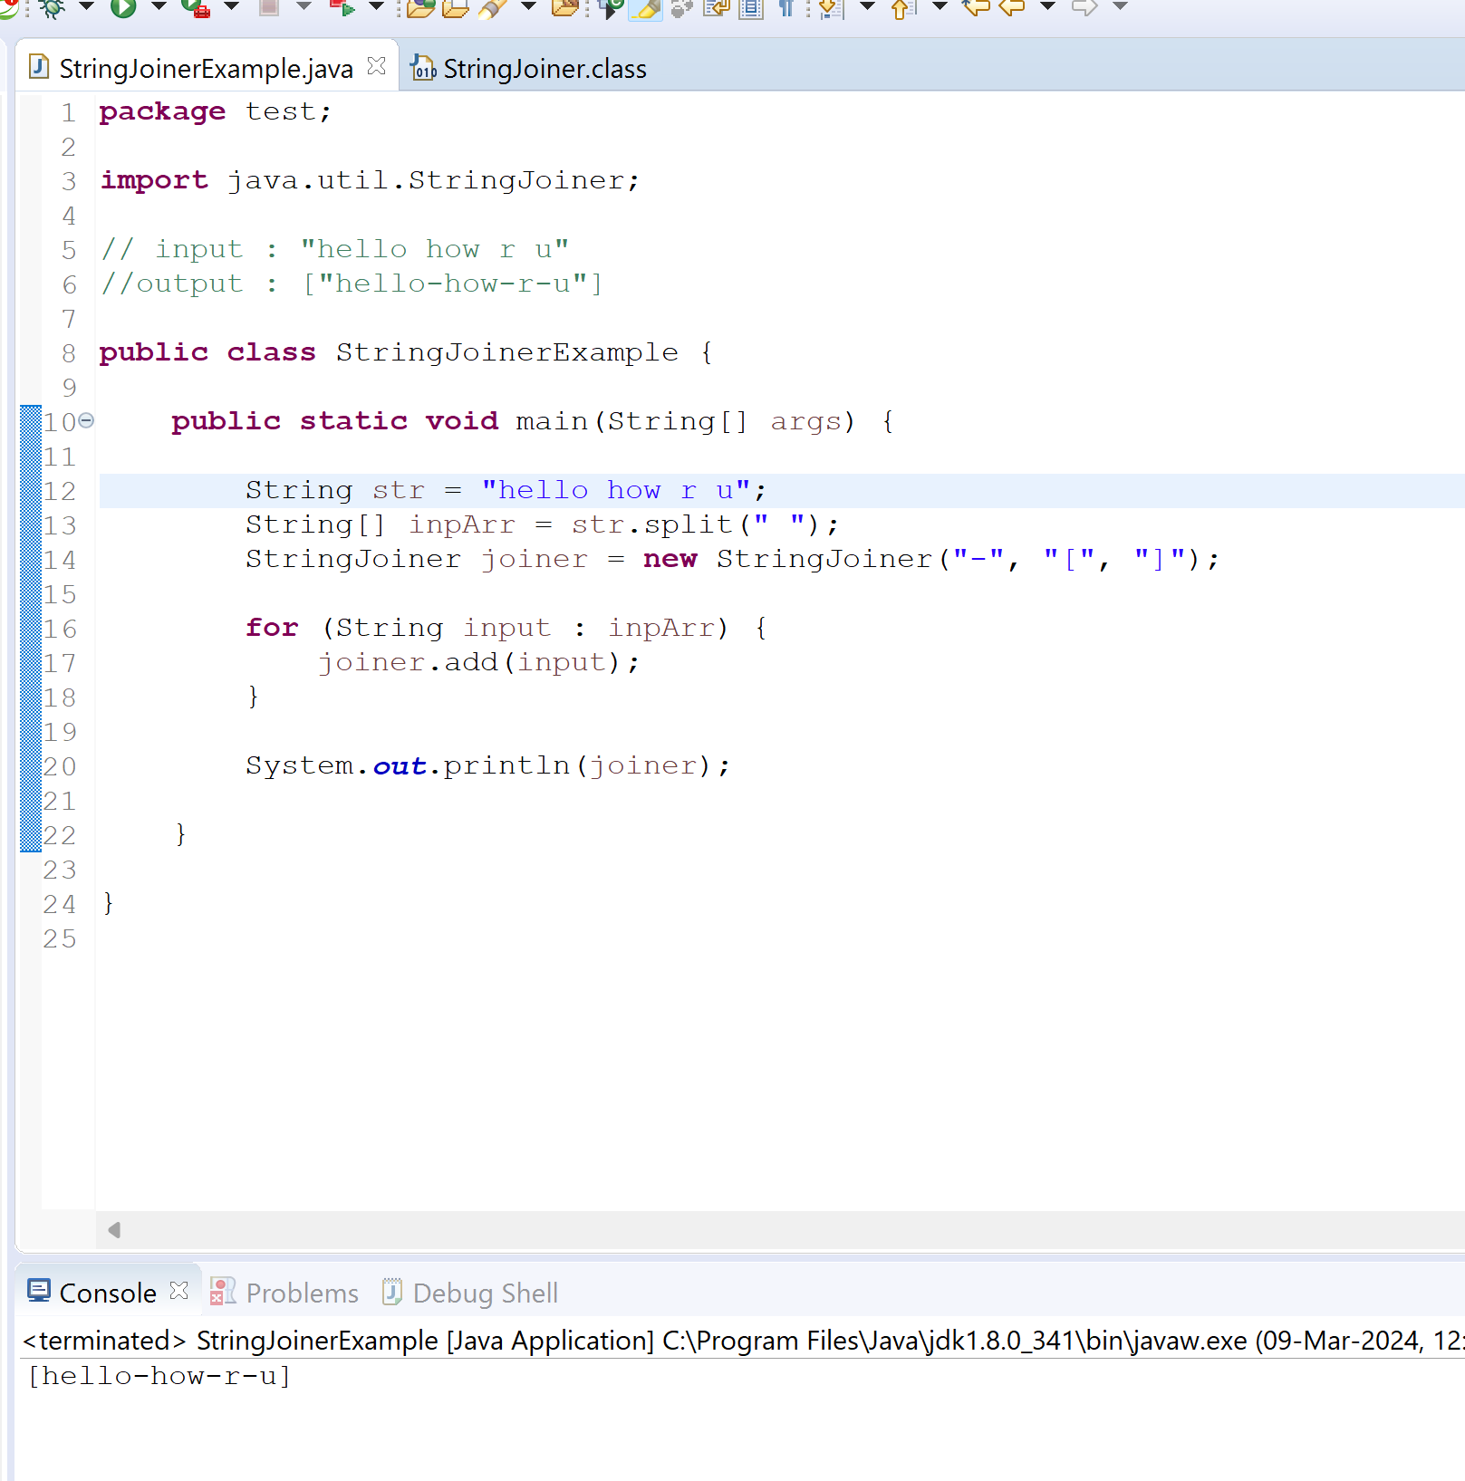

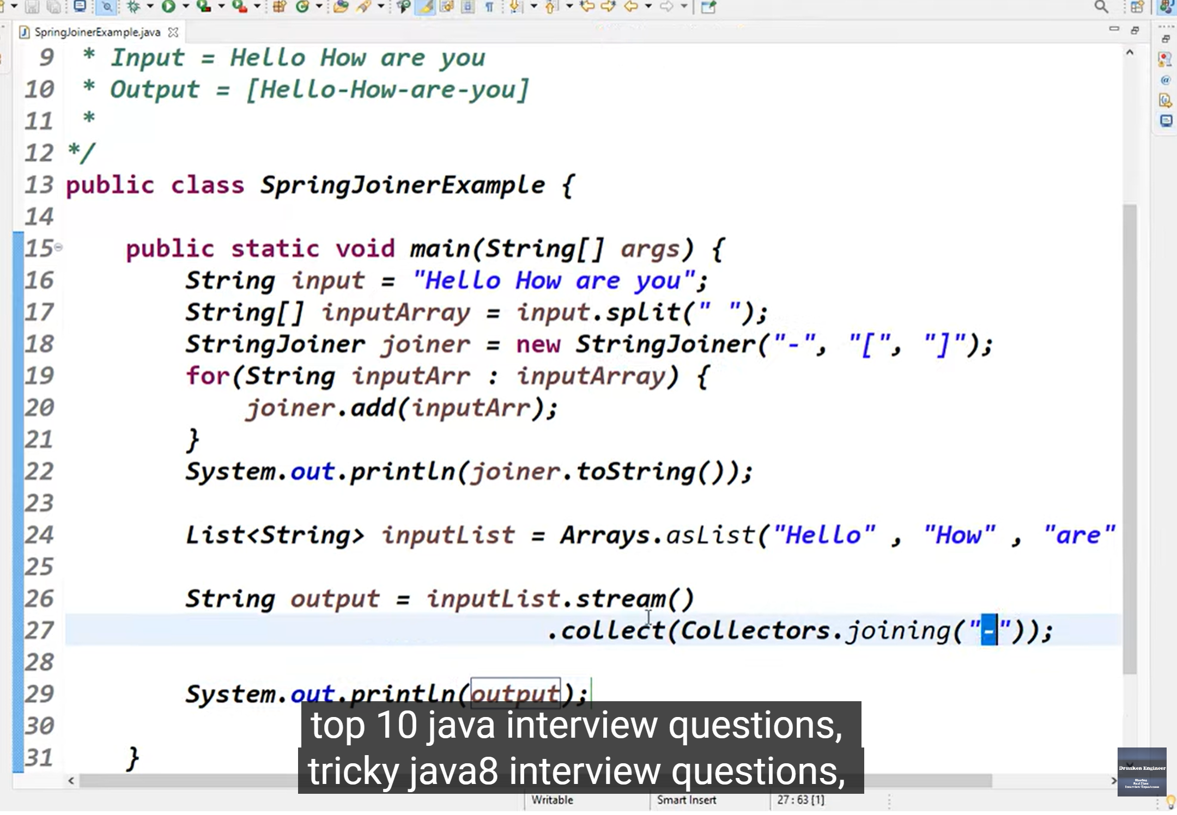

**Prog 8 : performing stream operation on string**

**Chars :** return intStream of char values.

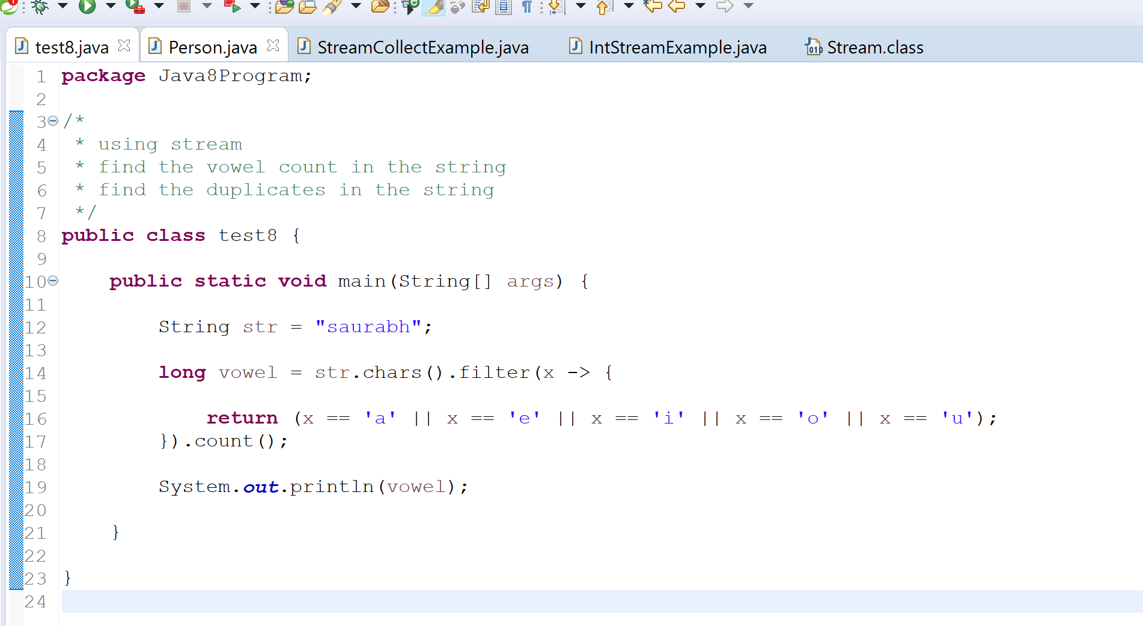

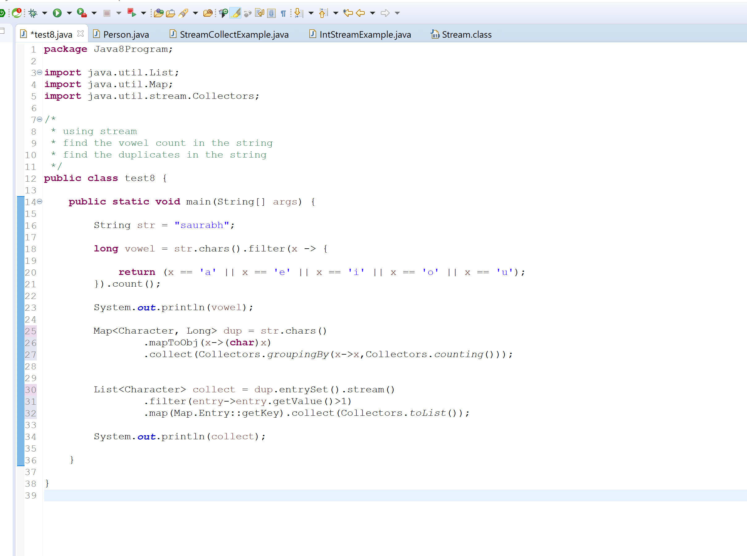

**9 : java 8 coding interview**

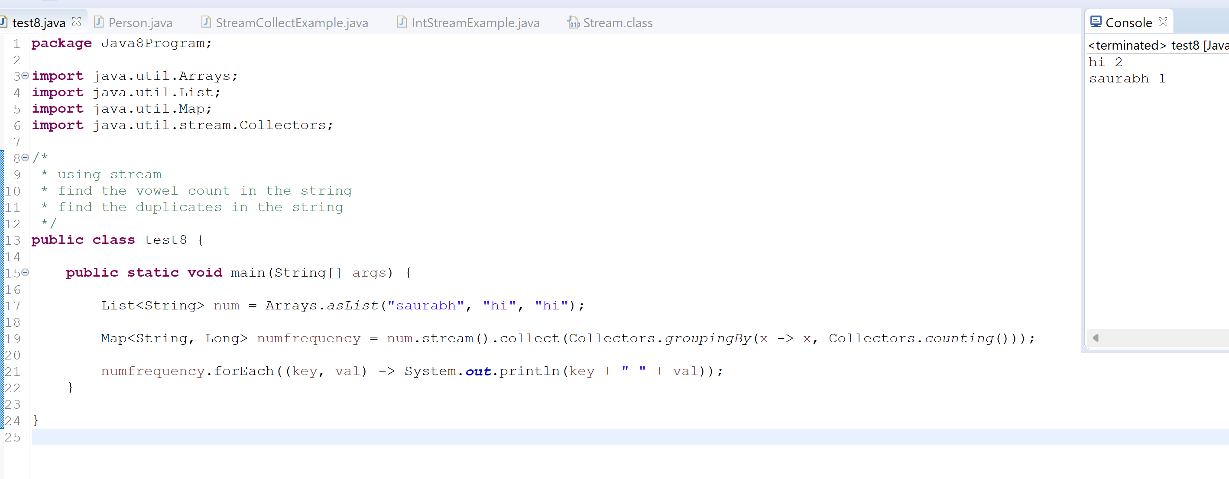

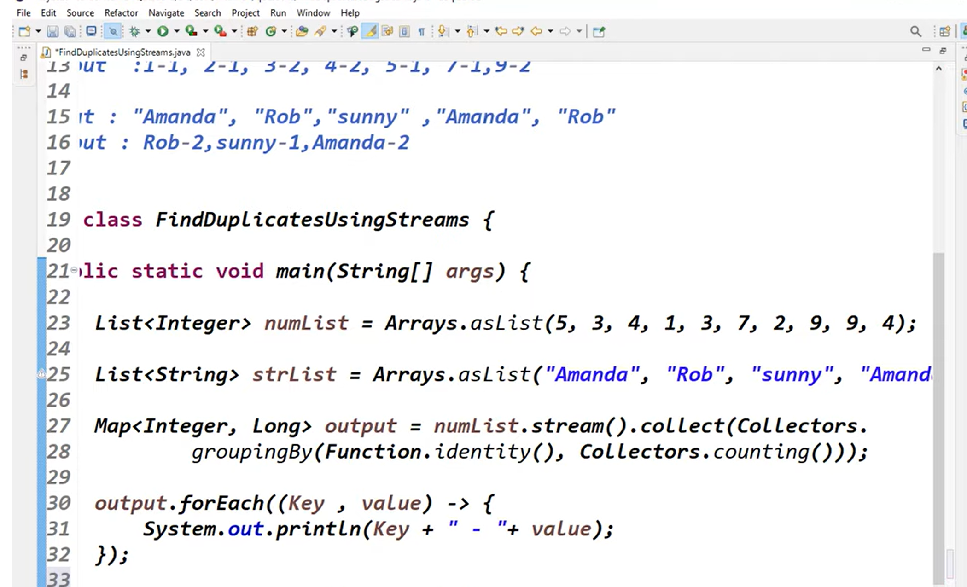

**Function.identity :** Returns a function that always returns its input argument.

**10 wipro java 8 interview question**

**Find max and min salary of employee**

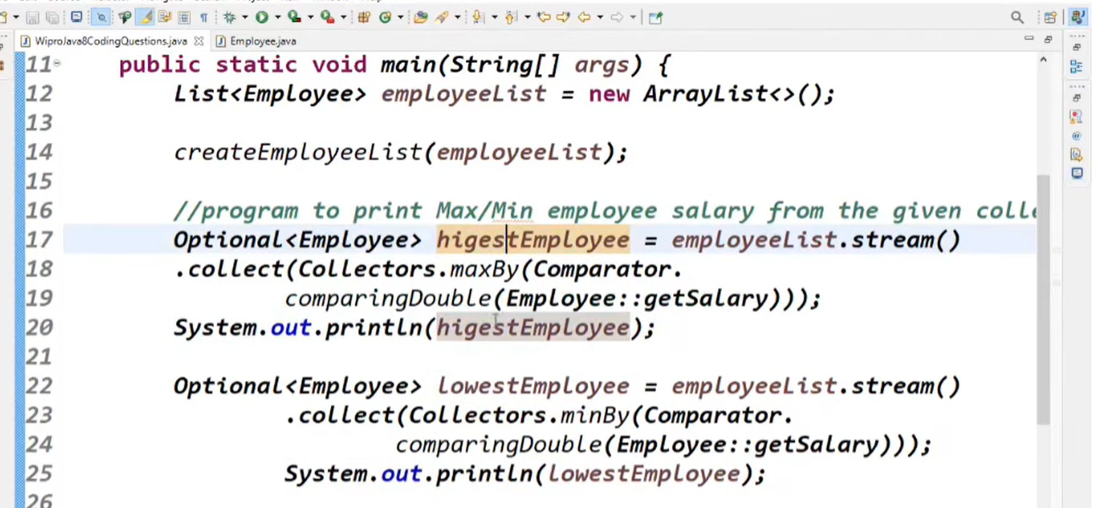

**11 :- find second element using java 8**

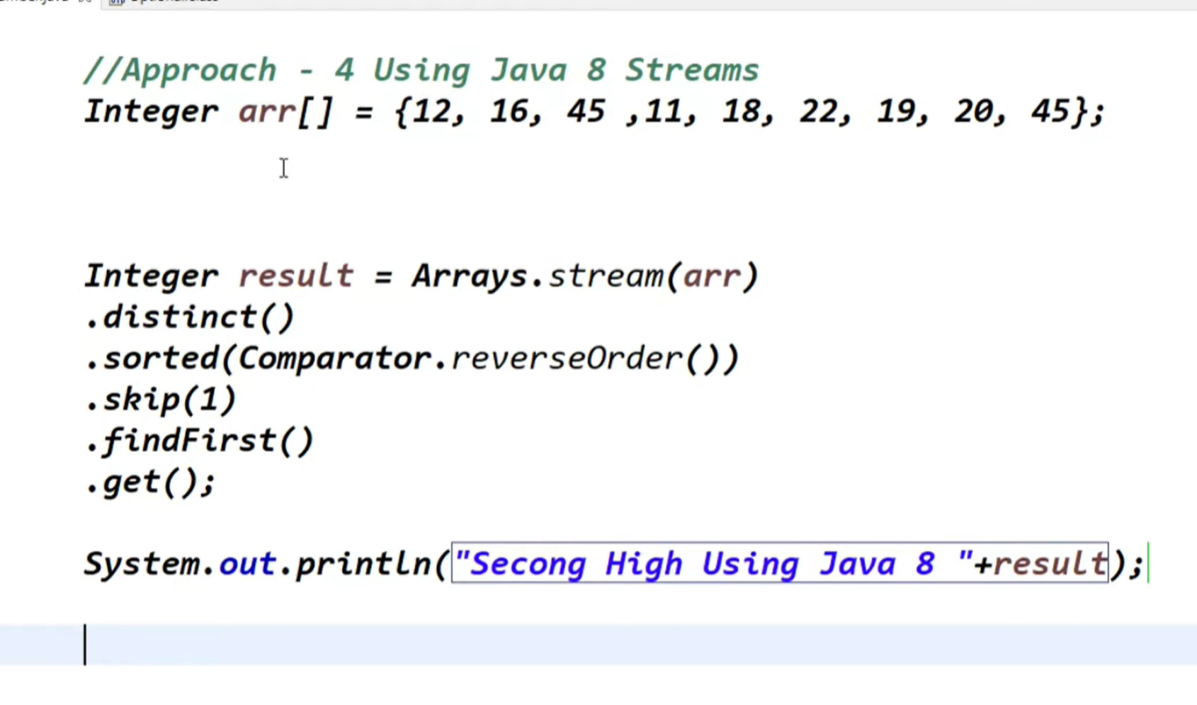

[Find the first non repeated character in a given string input](https://www.java-success.com/find-first-non-repeated-character-given-string-input/)



